**The Suburban Parks Program is creating a more connected, immersive and shared open space network across Melbourne, where our waterways, trails and cool, green streets meet local pocket parks, urban parks and bushland.**

Since 2018, the Victorian Government has committed over $315 million through the Suburban Parks Program to create, connect, plan for and upgrade more than 6,500 hectares of open space across metropolitan Melbourne.

# What is the Plenty River Trail project?

**Why create and upgrade parks?**

* to improve community health and wellbeing
* to protect nature
* to strengthen cultural heritage
* to address climate change
* to attract jobs, investment, skilled people, and visitors to Melbourne’s growing suburbs.

Through the Plenty River Trail project, Parks Victoria are creating 19 kilometres of trails and links at Plenty Gorge Park.

The new trail will become a primary trail between Doreen and University Hill in Bundoora.

Visitors will be able to use the new trails for walking, running, cycling, scooting and on-lead dog walking. The trail between Bridge Inn Road and Hawkstowe will also be suitable for people with prams and wheelchairs.

The trail will also link to the Mernda and Hawkstowe railway stations, and enhance community access to Plenty Gorge Park.

# When will the trail open?

Plenty Gorge Park is open for visitors to enjoy today.

Parks Victoria is delivering the trail in stages. See the [Parks Victoria website](https://www.parks.vic.gov.au/projects/melbourne-region/plenty-gorge-park-upgrades) for details.

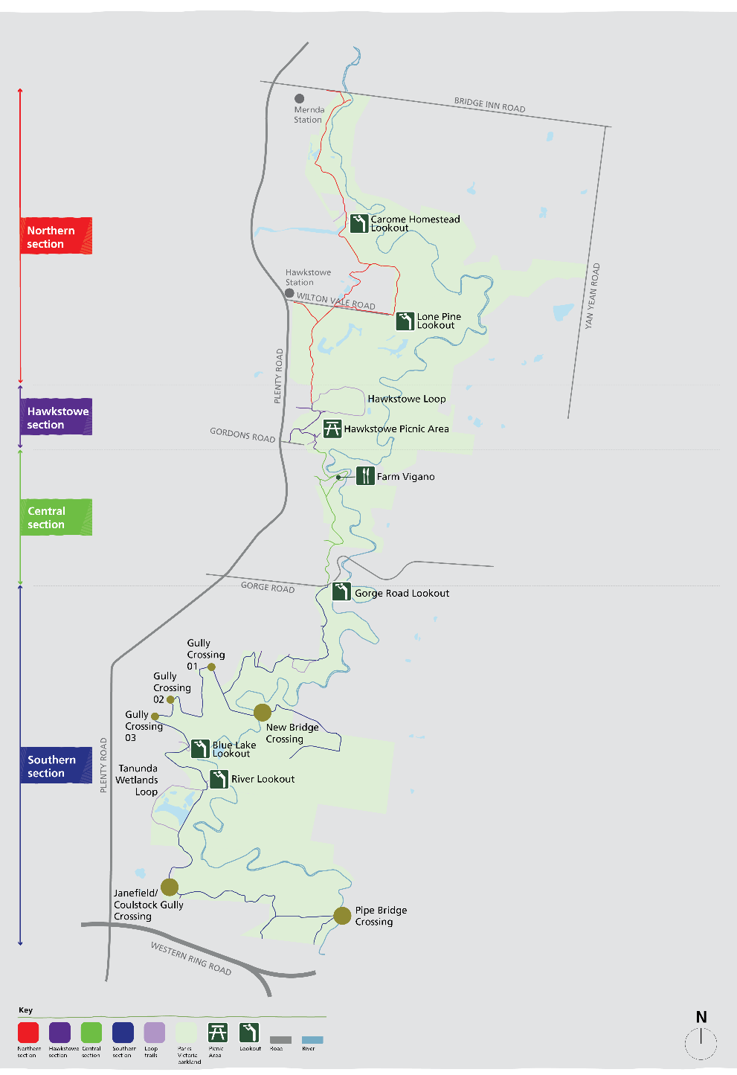

**Location**

Plenty Gorge is about 35 kilometres north -east of Melbourne’s CBD, on the land of the Wurundjeri Woi-wurrung People.

# Who are the project partners and stakeholders?

Parks Victoria is delivering the project with support from the Department of Energy, Environment and Climate Action. Parks Victoria is working with the Wurundjeri Woi-wurrung Cultural Heritage Aboriginal Corporation to ensure the park’s cultural values are protected during and after construction.

|  |
| --- |
| State Governement of Victoria logo© The State of Victoria Department of Energy, Environment and Climate Action 2025  Creative Commons logoThis work is licensed under a Creative Commons Attribution 4.0 International licence. To view a copy of this licence, visit <http://creativecommons.org/licenses/by/4.0/>. ISBN 978-1-76105-468-6 (print). Disclaimer: This publication may be of assistance to you but the State of Victoria and its employees do not guarantee that the publication is without flaw of any kind or is wholly appropriate for your particular purposes and therefore disclaims all liability for any error, loss or other consequence which may arise from you relying on any information in this publication. All photos © Parks Victoria.  ­­**Accessibility**: **If you would like to receive this publication in an alternative format, please email suburban.parks@deeca.vic.gov.au.** |

# Where can I find more information?

Further information can be found on the [Parks Victoria website](https://www.parks.vic.gov.au/projects/melbourne-region/plenty-gorge-park-upgrades).

You can email the project team at: [engage@parks.vic.gov.au](mailto:engage@parks.vic.gov.au).

**Wurundjeri Woi-wurrung Elders are working on cultural heritage assessments. Its findings are integral to planning and will inform the final designs and installation of infrastructure.**