**The Suburban Parks Program is creating a more connected, immersive and shared open space network across Melbourne, where our waterways, trails and cool, green streets meet local pocket parks, urban parks and bushland.**

# Since 2018, the Victorian Government has committed over $315 million through the Suburban Parks Program to create, connect, plan for and upgrade more than 6,500 hectares of open space across metropolitan Melbourne.

# What is the Cardinia Creek Regional Parklands project?

**Why create new parks?**

* to improve community health and wellbeing
* to protect nature
* to strengthen cultural heritage
* to address climate change
* to attract jobs, investment, skilled people, and visitors to Melbourne’s growing suburbs.

# The Cardinia Creek Regional Parklands project has endorsed a Future Directions Plan 2022, to guide the expansion of over 600 hectares of public open space in Melbourne’s south-east between Berwick to Clyde. The Future Directions Plan was developed in collaboration with the Parklands Partnership Group.

The project will connect existing parks including:

* Cardinia Creek Parklands at Inglis Road
* Beaconsfield Flora and Fauna Reserve
* Beaconsfield Recreation Reserve
* Cardinia Creek Nature Reserve
* Akoonah Park Reserve
* Bob Burgess Reserve
* Cardinia Creek Retarding Basin
* Manna Gum Park
* Mick Morland Reserve

# A new walking and cycling path has been constructed south of Inglis Road in Berwick, to increase access in the parklands. A new boardwalk bridge, seating, and tables have also been installed.

# When will the parklands open?

Many areas of the Cardinia Creek Regional Parklands are open for visitors to enjoy now. For more information on areas open to visit now within the parklands, please visit the [Suburban Parks Program website](https://www.exploreoutdoors.vic.gov.au/investing-in-outdoors/suburban-parks-program/large-suburban-parks/cardinia-creek-regional-parklands).

Additional upgrades will be opened in stages. .

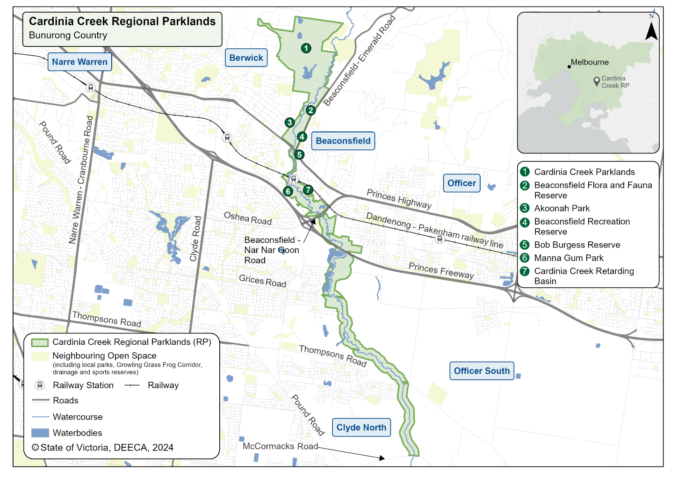

**Location**

The expanded parklands are located between Berwick and Clyde along Cardinia Creek, on Bunurong Country.

# Who are the project partners and stakeholders?

The Department of Energy, Environment and Climate Action lead project delivery and support the Parklands Partnership Group which includes:

* Bunurong Land Council Aboriginal Corporation
* City of Casey
* Cardinia Shire Council
* Melbourne Water
* Parks Victoria

**The cultural values mapping undertaken by Bunurong Elders is integral to parkland planning and had created an improved understanding and respect for Bunurong values around the Cardinia Creek.**

|  |
| --- |
| State Governement of Victoria logo© The State of Victoria Department of Energy, Environment and Climate Action 2025  Creative Commons logoThis work is licensed under a Creative Commons Attribution 4.0 International licence. To view a copy of this licence, visit <http://creativecommons.org/licenses/by/4.0/>. ISBN 978-1-76105-468-6 (print). Disclaimer: This publication may be of assistance to you but the State of Victoria and its employees do not guarantee that the publication is without flaw of any kind or is wholly appropriate for your particular purposes and therefore disclaims all liability for any error, loss or other consequence which may arise from you relying on any information in this publication. All photos © Parks Victoria.  ­­**Accessibility**: **If you would like to receive this publication in an alternative format, please email** [**suburban.parks@deeca.vic.gov.au**](mailto:suburban.parks@deeca.vic.gov.au)**.** |

# Where can I find more information?

Further information can be found on the [Suburban Parks Program website.](https://www.exploreoutdoors.vic.gov.au/investing-in-nature/suburban-parks-program/large-suburban-parks/cardinia-creek-regional-parklands)

You can email the project team at:

[suburban.parks@deeca.vic.gov.au](mailto:suburban.parks@deeca.vic.gov.au)